**Assignment 11**

**TCOD01**

mydb> db.createCollection('Student')

{ ok: 1 }

mydb> db.Student.insert({id: '1', name:'A', fees: 30000})

{

acknowledged: true,

insertedIds: { '0': ObjectId("635e66fe322c59c36026ba0b") }

}

mydb> db.Student.insert({id: '2', name:'B', fees: 50000})

{

acknowledged: true,

insertedIds: { '0': ObjectId("635e6716322c59c36026ba0c") }

}

mydb> db.Student.insert({id: '3', name:'C', fees: 70000})

{

acknowledged: true,

insertedIds: { '0': ObjectId("635e6725322c59c36026ba0d") }

}

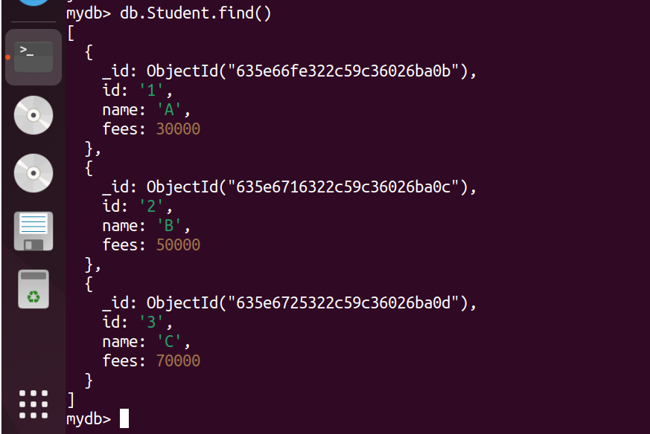

mydb> var mapfunction = function() {emit(this.name, this.fees)}

mydb> var reducefunction = function (key,values){return Array.sum(values)}

mydb> db.Student.mapReduce(mapfunction, reducefunction, { 'out': 'Result_mapReduce' })

{ result: 'Result_mapReduce', ok: 1 }

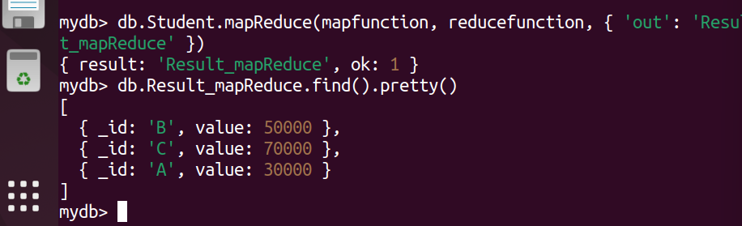

mydb> var mapfunction = function() {emit(this.id, this.fees)}

mydb> var reducefunction = function (key,values){return Array.sum(values)}

mydb> db.Student.mapReduce(mapfunction, reducefunction, { 'out': 'Result1_mapReduce' })

{ result: 'Result1_mapReduce', ok: 1 }

